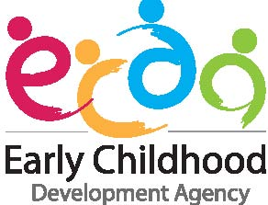

ECDA SCHOLARSHIP APPLICATION FORM
(Applicant’s Write-up and Recommendation by Nominating Centre)

Instructions to Applicants:
- Please download and complete all items in this application form. For items which are not applicable, please indicate ‘N.A’. Any omission of information requested in the application form or of supporting documents will cause delay and may render the application void.
- Section 1 and 2 of this form are to be completed by the applicant.
- Section 3 and 4 of this form are to be completed by your supervisor/reporting officer at the nominating centre .
- Do refer to Annex A on the steps to insert a digital signature into this application form.
- Please attach this completed form under Section (4) Supporting Documents on FormSG online application form.

1) APPLICANT’S PERSONAL PARTICULARS
Name as in NRIC or Passport (Please underline surname):  Choose a salutation. : Click here to enter name. |  | NRIC (Choose an item.):  Click here to enter text.
2) APPLICANT’S WRITE-UP
This section is to be completed by the applicant. Please share with us the following:
a) Your personal philosophy and professional aspirations as an Early Childhood Educator; and
b) Your plans to contribute to your organisation and/or the early childhood sector during and/or after your Degree or Master studies, including how your studies will enable you to do so?

(Word Limit: 800 words)

Click here to enter text.

3) ENDORSEMENT BY NOMINATING CENTRE
☐ The Centre acknowledges that all information provided in Section 4 are true to the best of our knowledge and we have not willfully suppressed any material fact.

☐ The Centre confirms that the status of the applicant’s Occupational Title¹ in ONE@ECDA is accurately reflected of his/her job role as at the point of Scholarship application.

☐ If the applicant is awarded the ECDA Scholarship, the Centre agrees to partner him/her in his/her professional development journey (Refer to Annex B).

(Please Tick)

¹ To be eligible for the ECDA Scholarship, the applicant must be an ECDA-certified L2 educator who meets the relevant skills and competencies required for at least a Senior Infant Educator, Senior Early Years Educator or Senior Preschool Educator, as per the Occupational Title reflected in ONE@ECDA.

Name of Nominating Centre:  Click here to enter text.  Centre Code:  Click here to enter text. | Name of Supervisor/Reporting Officer:  Click here to enter text.  Designation of Supervisor/Reporting Officer:  Click here to enter text.  Signature of Supervisor/Reporting Officer:
Address of Nominating Centre:
Click here to enter text.

Contact No :
Click here to enter text.

Email Address:
Click here to enter text.

4) RECOMMENDATION BY NOMINATING CENTRE
Please provide an assessment on a) the relevance of the Bachelor or Master Degree programme to the applicant’s duties and/or career development, and b) the applicant’s ability and potential to lead and/or contribute to the organisation and/or early childhood sector. Please highlight key evidences to support your assessment.

(Word Limit: 500 words)

Click here to enter text.

ANNEX A
How to Add A Digital Signature

To add a digital signature, the signer can i) type a signature, ii) upload a picture of an inked signature, or iii) ‘draw’ a signature by using the touch screen or inking feature (only applicable for tablet PC). Please refer to the steps below.

Step 1
Right-click the signature line and select ‘Sign’.

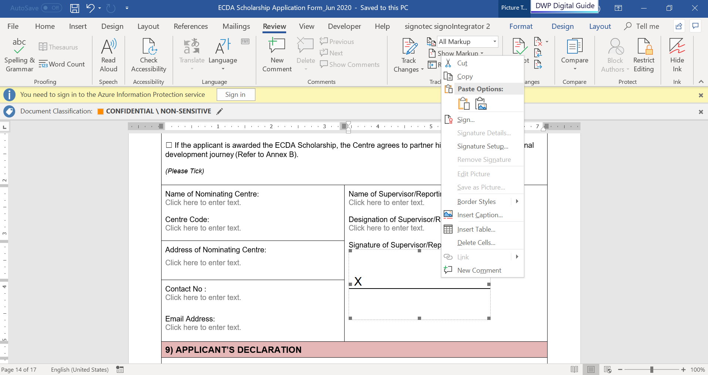

Step 2

Option (a): To add a printed version of your signature, type your full name in the box next to the ‘X’, or

Option (b): To select an image of your written signature, click ‘Select Image’. Click on ‘Browse’ to search for your signature image and insert file, or

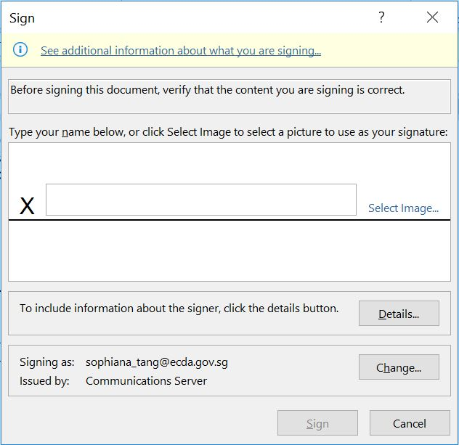
Option (a)
Option (b)

Option (c): To add a handwritten signature, sign your name in the box next to the ‘X’ by using the touch screen or inking feature (Note: This option is only applicable for tablet PC).

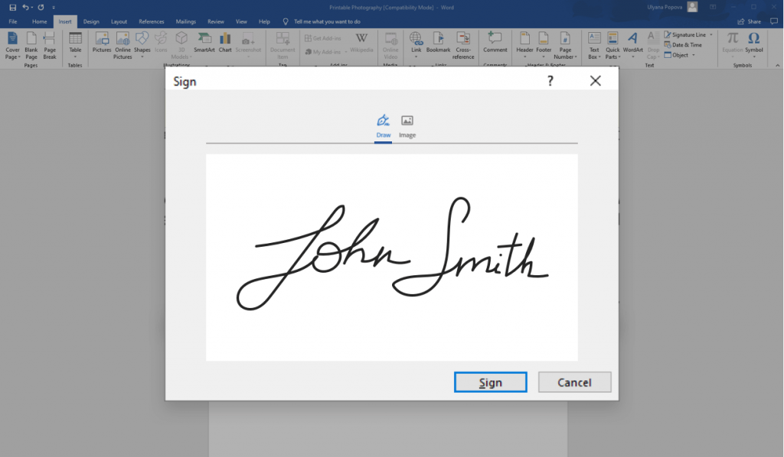

Step 3
Select ‘Sign’. Your signature will appear on the signature line.

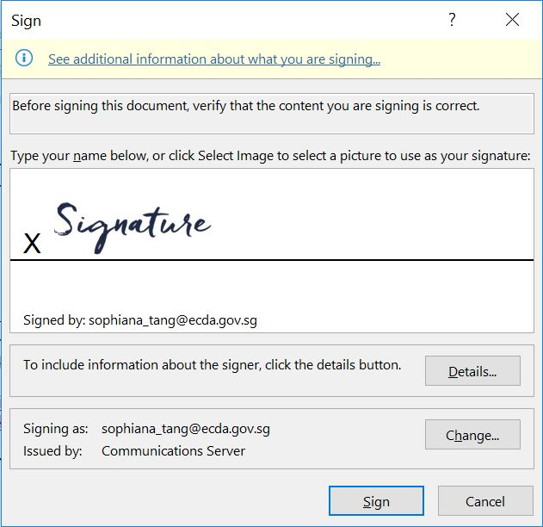

ANNEX B
Professional Development Journey

The flow chart below is an illustration of an ECDA Scholarship Recipient’s Professional Development Journey, in partnership with the nominating centre and ECDA.
Start of Programme/
Award
Recipient to track and reflect on their learning progress

- Recipients to share their plans for centre/sector contributions during their bond periods. ECDA continues to engage and support recipients in their plans till completion of bond.

- Progress report submitted to ECDA.

- Nominating Centre receives a lump sum centre subsidy in recognition of centre’s co-partnership.
Completion of Programme
- Recipient and Centre Supervisor proactively work towards achieving the desired learning outcomes together, maintaining a progress report and sharing it with ECDA twice a year.

- ECDA engages recipients and centres annually, focusing on the learning needs identified.

Throughout Programme
- Recipient and Centre Supervisor jointly submits a Professional Development Plan to ECDA.

- The plan charts the recipient’s professional growth and contributions to the centre and sector throughout your studies, with reference to your learnings from the Bachelor or Master Degree.

- Centre supervisors would show how they intend to support the recipient in achieving this plan.

